The following is a Portfolio that was submitted for our Developing a Sense of Responsibility class.

We are providing it as an example of a Portfolio that you can use as you complete your Portfolio. It shows the level of reflection and depth the DOE is looking for in your answers and how to complete the “captions” requirement for each section.

We have also posted the Portfolio guidelines that the DOE has published for you to download on our website, so between the two, you should have a clear idea of what is required of you for the Portfolio.

Please let us know if you have any questions or concerns.

Aloha,
Joe, Dave, Allan & Emily

Developing a Strengthened Sense of Responsibility:
Addressing the “R” in the Na Hopena
A’O Outcomes Framework

SECTION 1.
Need Assessment Rationale: Participants will identify 2 activities/lessons that you believe would be the most appropriate and beneficial to their students in strengthening a sense of responsibility. Each of the 2 assessments must address the rationale for the selection of the activities/lessons. A caption is required for each assessment (2 captions). (Student Centered)

Activity #1
Activity name: What is responsibility?

Rationale for choosing this activity (provide examples to support your rationale).
Students in this generation don’t fully understand what it means to be responsible. Back in the day, students used to find jobs to earn spending money. Jobs included yard work, washing cars, working at the local grocery store, drug store, or gas station. These jobs not only provided the spending money that the students wanted, it also taught them about being responsible – getting to work on time, performing a meaningful task well, developing honesty, trustworthiness, and much, much more. Today, for example, students are given money to spend without having to work for it, and with that is the loss of the opportunity to gain that work experience of being independently responsible.

This activity is important for students in developing their sense of responsibility because employers are noticing that young people entering the workforce don’t have this sense of wanting or needed to be responsible. We hear the word “entitlement” a lot when young people are described in this generation. Their mentality is not that “I’m working for you and this is my responsibility in this workplace.” The mentality is more like “Does this workplace fit my needs and what do I get out of this?”

Activity #1 Caption
What the document is? This document is the rationale behind the activity that will explore the meaning of “Responsibility.” The rationale describes why this activity is important for students in developing their sense of responsibility, what it will create in students, and the importance of how this feeling is for students’ learning capacity and growth. Examples are given to support the rationale.
Why it is evidence? This is evidence because the rationale addresses the reason and importance for teaching responsibility to students. It is important to teach because as a whole, students today are not given as many opportunities to practice Responsibility at home and outside the home. Responsibility today needs to intentionally be taught so students understand how meaningful this is to lead productive lives. This is evidence because it addresses a critical need in our society. That critical need is to instill the importance of taking on responsibility and using it to better self and society.
What it is evidence of? This is evidence of intentionally teaching students what responsibility is and what it looks like. Students will be given activities that demonstrate responsibility. Students will read a story, discuss, and watch a couple of videos. From this, students will broaden their understanding of responsibility and how responsibility affects others.

Activity #2
Activity name: What is your kuleana and how can you make a difference?

Rationale for choosing this activity (provide examples to support your rationale).
The idea behind this activity is to create in students the understanding of what responsibility really means and give students the opportunity to practice being responsible and affecting a positive change in oneself and in others. In Hawaiian, responsibility is “kuleana” and kuleana is a mutual sense of responsibility. For example, if I take care of the land, the land will in turn produce for me. If I don’t overfish, there will be enough food for future generations. Kuleana type of responsibility is always attached to someone or something else – it’s not something in isolation. My actions always affect someone or something else and if my actions are done right, the outcome will be a positive one.

Understanding kuleana is everything in students’ learning capacity and growth. If understood properly, it can drive everything that they do. When students understand the true meaning of kuleana, they take a more proactive role in their learning. When given an assignment, they will do the assignment knowing and understanding that the assignment is a means to an end. The assignment is not an isolated task. The attitude and action behind the assignment is preparing them to be successful at independent study or practicing good work ethics. In the bigger picture, it is a step towards acquiring the necessary knowledge to finishing school well and moving on to post-secondary education, or entering the workforce. The better the achievements gained in school by practicing responsibility, the better the opportunities will be for students. (And this can be applied to students who participate in extra-curricular activities as well – sports, drama, art, music, etc.) Students will understand that kuleana is not just a one-time action, but a means to more benefits after the initial the action.
Activity #2 Caption
What the document is? This is the rationale behind Activity #2 which is the reasoning for having the students understand the Hawaiian term for responsibility which is “kuleana.” This rationale explains why students need to intentionally practice kuleana. Like a muscle, it needs to be used and exercised so when faced with real opportunities to practice kuleana, the automatic reflex will be to show kuleana naturally.
Why it is evidence? This is evidence because this activity addresses the need for intentionally teaching kuleana. It’s not just content and part of the curriculum, or it’s not just something on the agenda. Kuleana can be taught at any time during any time of day, wherever it lends itself to give students the opportunity to see/use it in real time. This is important because when students see the need for it and see the positive impact it can make in their lives and the lives of others, they will begin to practice kuleana in other areas of their lives. This is evidence because it addresses a critical need in our society. More and more people are not demonstrating kuleana and instead are putting blame on others.
What it is evidence of? This is evidence of empowering students with a much needed attribute that would perpetuate and positively impact themselves and those around them. Students will practice kuleana by participating in an egg activity. Students will take care of a boiled egg – treat it like a little human being – for the weekend. Students will also choose an area to really focus on practicing kuleana – self, family, friends, school, or community. This activity will give students the opportunity to put kuleana into action, discuss the outcome and benefits.
SECTION 2.

Action Plan (Proposal): Participants will propose 2 actions and describe how they plan to implement each activity/lesson. A caption is required for each proposed action (2 captions). (Activity/Action Centered)

Activity #1
Action: For Activity #1, students will explore different definitions, explanations, examples of the word “Responsibility” through a picture, a story, videos, reflection/discussion, and looking up the definition. Students will jot down information about what they learned from each of these explorations on a concept web.

How they plan to implement it:
Part 1: Students will…
- Look at a picture of a bird sitting on her egg. Questions will be posed such as:
  - “What do you see in this picture?”
  - “What is the bird doing to the egg?”
  - “Why is she sitting on the egg?”
  - “Is this what your mother did for you?”
  - “Why did your mother do that for you?”
- In a large group discussion, come to the conclusion that the bird is being responsible for the egg so that the egg hatches a healthy baby bird.
Part 2: Students will…
- Hear the story of “Horton Hatches the Egg”
- In pairs, compare and contrast the characters Horton and the mother bird using a Venn Diagram in terms of responsibility.
- Individually create a concept web defining the word “Responsibility” and jot down anything that they found would define “Responsibility.”

Part 3: Students will…
- Watch two videos to boost students’ understanding of being responsible.
  - Amazing Kids of Character: Responsibility
  - Stop Making Excuses & Own Your Actions
- Add to the concept web any other descriptions of what it means to be responsible after watching the videos.

Part 4: Students will…
- Look up the definition of Responsibility.
- Compare that definition to the definitions/descriptions already on their concept web and add anything new.
Part 5: Students will…
- As a large group, come up with a list of all the responsibilities they currently have (chores, siblings, etc.) and this list will be revisited after Activity #2 to see what they can add to the list to show what more they have learned about “Responsibility.”

Activity #1 Caption
What the document is? This document is the plan of action that students will participate in to explore different definitions, explanations, and examples of the word “Responsibility.” The document outlines specifically how the plan will be implemented. It explains how the information is going to be explained to students, what the students are supposed to do, what the students will formulate, and how the students will participate.
Why it is evidence? This is evidence because it addresses the rationale and shows how students will come to the conclusions outlined in the rationale. This is important because as stated in the rationale, students today do not have the same lifestyle, mentality, inner drive to experience “Responsibility” on their own or within their own family, so the idea is to intentionally teach students what this looks like, what the benefits are for self and society, and how to develop an understanding to the point of demonstrating responsibility instinctively. This is evidence because it addresses the need to explicitly teach this attribute, starting at a young age to begin to instill the desire to be responsible and demonstrate responsibility in different facets of a student’s life.
What it is evidence of? This is evidence of a teacher methodically planning activities that exposes students to various forms of responsibility and providing students with the opportunity to practice responsibility in a “laboratory” so to speak, to help students develop that desire to demonstrate responsibility in everyday life. The hope is that if the activity is strategically implemented, students will increase their understanding of what it means to be responsible practice it more often. This is evidence of a teacher guiding students through a mirage of activities that will help them to see how doable and desirable it is to practice being responsible because of the positive difference they are making in their realm of influence.

Activity #2
Action: For Activity #2, students will use what they’ve learned from Activity #1 and put all of that understanding of “Responsibility” into action. A deeper understanding of “Responsibility” will be introduced. Students will transition from the word “Responsibility” to the term “Kuleana.” To reiterate, “Kuleana” type of responsibility is always attached to someone or something else, it’s relational and the relationship is reciprocating. It’s not something done in isolation and there are always positive by-products. One person’s actions always affect someone or something else and if that person’s actions are done correctly, the outcome is usually a positive one.

Students will practice first with a boiled egg that represents another human being, and then students will implement their understanding of kuleana in real time by practicing on self, with family, friends, school, or the community.

How they plan to implement it:
Part 1: Students will…
- Participate in a whole group discussion that transitions the word “Responsibility” to the word “Kuleana”
  - Examples of “Kuleana” – If I am responsible with taking care of the land, the land will produce a good harvest for me. If I don’t over-fish the ocean, there will be plenty of food for the next generation.
  - “Kuleana” is a mutual, reciprocating relationship that if you do something well and/or with a good heart/attitude, you will get something good in return. Not that you do to get, but that you are rewarded for your efforts.
Part 2: Students will…
- Boil an egg at home and for one weekend take care of the egg as though it were another human being.
  - The egg needs to go wherever they go and students need to protect it from cracking.
  - Students can be as creative as possible (drawing a face on the egg, making clothes for the egg, etc.) and can create a holder for the egg.
- Record how they were responsible for it and how they kept it safe.
- Return on Monday and as a class discuss what they did and what it means to show kuleana.
- Discuss that even though the egg could not “give back” to them, students did receive something in return – feeling of accomplishment, care, etc. and this may be the case when they do Part 3 practicing kuleana with family, friends, school, or community.
Part 3: Students will…
- Choose either family, friends, school, or community and demonstrate how they will make a positive difference with that chosen person/group of people for one week.
- Create a plan of action as to how they will practice demonstrating kuleana.
- Share their plan with another classmate, collect feedback from that individual, and make adjustments to improve their plan of action.
- Upon completion of the project, students will reflect on what happened and what more they learned about being responsible. Then, students will share out with the rest of the class.
Part 4: Students will…
- As a large group, revisit the list of all the responsibilities created at the end of Activity #1 (which listed what responsibilities they had prior to Activity #2 such as chores, siblings, etc.) and then students come up with additions to the list to show what more they have learned about “Responsibility” – “Kuleana.”

Activity #2 Caption
What the document is? This document is the plan of action to implement what was learned in Activity #1 about the Responsibility. This document also shows the transition of “Responsibility” to “Kuleana” and that kuleana has a deeper meaning to the word “Responsibility.” This plan of action has three parts, with each part building upon the previous part. Students started with exploring the word kuleana, then applied kuleana using a boiled egg, then lastly practicing kuleana with either family, friends, school, or community.

Why is this evidence? This is evidence because the evidence addresses the students putting what they learned from Activity #1 into action and making the transition from “Responsibility” to “Kuleana.” This is important because just gaining head knowledge about an important concept like responsibility isn’t meaningful unless that understanding is put into practice. Activity #2 gave students the opportunity to practice kuleana first with an object, then with people. It is evidence because it addresses a critical need in our society today that concepts like these need to be explicitly taught so that students are aware of the needs, are given the opportunity practice it and discuss it, and then take what they have learned and apply it in real life circumstances.
What it is evidence of? This is evidence of taking a concept that seems to be familiar and giving students the opportunity to talk about it, check their understanding of it, and guide them through the process of implementing it. This is evidence of methodically teaching students how to demonstrate kuleana and helping them to see how necessary it is in life today to perpetuate good relationships and practice being productive. This is evidence of an activity that gives students the means to exercise kuleana, discuss it and ask questions with peers and the teacher, and experience the results of it. The hope is that students will find the activity worthwhile and continue to practice kuleana on their own.

SECTION 3.

Instructor/Peer Feedback: Participants will receive feedback from the instructors and their peers in regards to the proposed activity/actions they plan to take. They will document feedback to confirm or refine the proposed activities/actions. They will document feedback to confirm or refine the proposed activities/actions. Feedback is required for each of the 2 actions. (Collaboration Centered on Teacher Growth)
Instructor/Peer Feedback Reflection Activity #1

Instructor feedback:

Peer feedback:
Peer #1: I think you want to highlight and explain how this project is deeply rooted in the Hawaiian culture. You want to highlight how this project is a culture-based approach and how it leads to success in multiple academic subject areas and life skills.
Peer #2: I like your list of activities for the lesson and was wondering if there's a place where you could have the students list the chores they are responsible for at their own home (or class)... maybe before the videos? And then at the end of Activity #2, part 3, they can relook at what they listed and how they could improve on it -- or come up with an entirely different thing to demonstrate responsibility.

INSTRUCTOR/PEER FEEDBACK REFLECTION CAPTION:
What the document is? The document is the feedback from the assigned instructor and two peers. The feedback is for the proposed activity/actions that intend to be implemented. The feedback indicates that for Activity #1, the term “kuleana” would be more effective and more meaningful if explained in the concept of the Hawaiian culture. The second feedback is suggesting a list of chores that can be revisited at the end of Activity #2.
Why it is evidence? This feedback is evidence of learning because it shows that as an educator, I only get better as a professional by seeking feedback from others who have different experiences than myself. Good educators are constantly reflecting on their practice and seeking ways to improve their craft to be more effective with students and increase student learning and achievement. This is evidence of learning because I got the feedback and incorporated the feedback to improve and enhance Activity #2 to make the activity deeply rooted in the Hawaiian culture and a more culture-based approach. For the second feedback, the idea to list chores and revisit the list at the end of both activities was incorporated to tie in everything that was learned from beginning to end. It is a nice culminating reflection for the students to see how much progress was made and how much more may be needed to get better at demonstrating “kuleana.”
What it is evidence of? This is evidence of the power of feedback to improve teacher practice. The feedback was used to enhance Activity #1 and future follow up activities. Having another “set of eyes” to review an activity prior to implementation is helpful in ensuring a better success rate for the students. It also gives the teacher more experience without having to go through the experience himself/herself.

Instructor/Peer Feedback Reflection Activity #2

Instructor feedback:

Peer feedback:
Peer #1: Explain the difference you want your students to make. Remember, you want to empower, engage, and excite your students about what they can learn and how they can use that knowledge to make a difference in demonstrating responsibility.
Peer #2: Could there be a charted list so the kids can see what they do as being "responsible"? Some kids might not realize (or forget) that what they do at home might be considered showing responsibility.
INSTRUCTOR/PEER FEEDBACK REFLECTION CAPTION:
What the document is? This is feedback from peers showing their point of view – teachers who have over 10 and 30 years of experience. Their feedback provides wisdom and insight on whether the activities would be age appropriate and effective. The feedback states that the impact students make practicing kuleana should be explained so that students are empowered and get excited about making a positive difference. The second feedback suggests to make a chart so that students can visibly see and be reminded of how they are to practice kuleana.
Why it is evidence? This is evidence of learning because the feedback provides different approaches to teaching more effectively using the concepts from this course. By sharing my activities with the course instructor, he can see if what I am proposing shows understanding of the concepts taught in this course and if those concepts as executed in my proposed activities would work effectively in the classroom. This is evidence of learning because the feedback was incorporated in the activities to enhance student engagement and student learning. The students felt more involved in the process of learning and with that buy-in, they were more motivated to really demonstrate kuleana for personal development instead of seeing this as just a class assignment.
What it is evidence of? This is evidence of the impact a few minor changes can make to an activity to make it that much more meaningful and effective for students. For this activity, the feedback added a deeper explanation of why it is important for the students to demonstrate kuleana. It’s more than just having the students behave well or look good. It’s an opportunity for students to really find the meaning behind their actions and to make it a genuine habit. The second feedback also made the lesson more meaningful as it addressed those learners that are more visual and need a way to track their actions.

SECTION 4.

Implementation: Participants will implement the activity/action for each student and document descriptions of the results through a case study. Participant will gather student evidence that will be included in the case study.

CASE  STUDY MANAGEMENT | Date of Action: April 2020  Activity #1: Students will explore different definitions, explanations, and examples of the word “Responsibility” through a picture, a story, videos, reflection/discussion, and looking up the definition. This will give students a broader definition of what responsibility is, what it looks like, and how it can be very impactful when practiced naturally and not forced.
Need(s) Addressed | Students in this class have responsibilities at home. Their responsibilities are usually chores or looking after younger siblings…something that they are told to do by their parents. They are responsible when asked, but don’t initiate responsibility on their own. They haven’t quite grasped the concept of taking responsibility when they see a need arise. They see their own responsibility. They see how they can control their own realm. However, they don’t quite see their responsibility as being a part of a greater responsibility either within their home, school, or community.
Summary of Action(s) | The idea with Activity #1 was by taking students through a series of discussions, stories, videos, and reflections and exposing them to a variety of definitions and understandings, students would understand that responsibility is something that should be done naturally and they should not wait to be asked or reminded to do something. That is the ultimate definition of responsibility where they are taking “responsibility” for their own actions to fulfill a responsibility. The idea is for the students to learn this intentionally so that when faced with the opportunity to demonstrate responsibility, they will act upon it instinctively and not wait for an adult to tell them what to do. Along with this Activity #1, positive praise would be given to students when they did demonstrate responsibility on their own. Students would be asked what they did around the house to show that they were fulfilling a responsibility and was not told or reminded by their mom or dad about it. The hope would be that when some share, others would hear and look for those moments when they could do the same in their home.
Result(s) of Action  (Student evidence) | 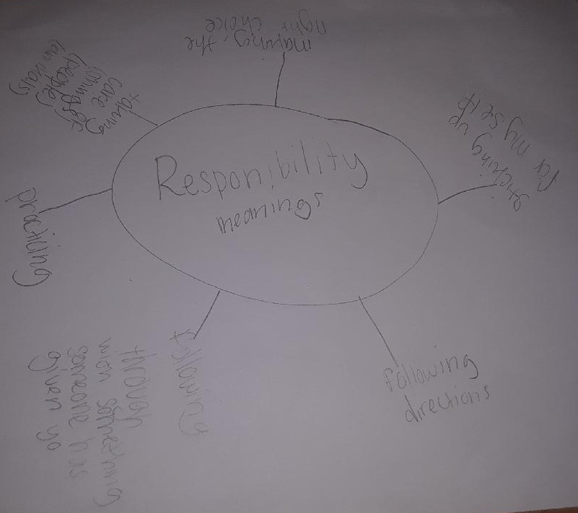  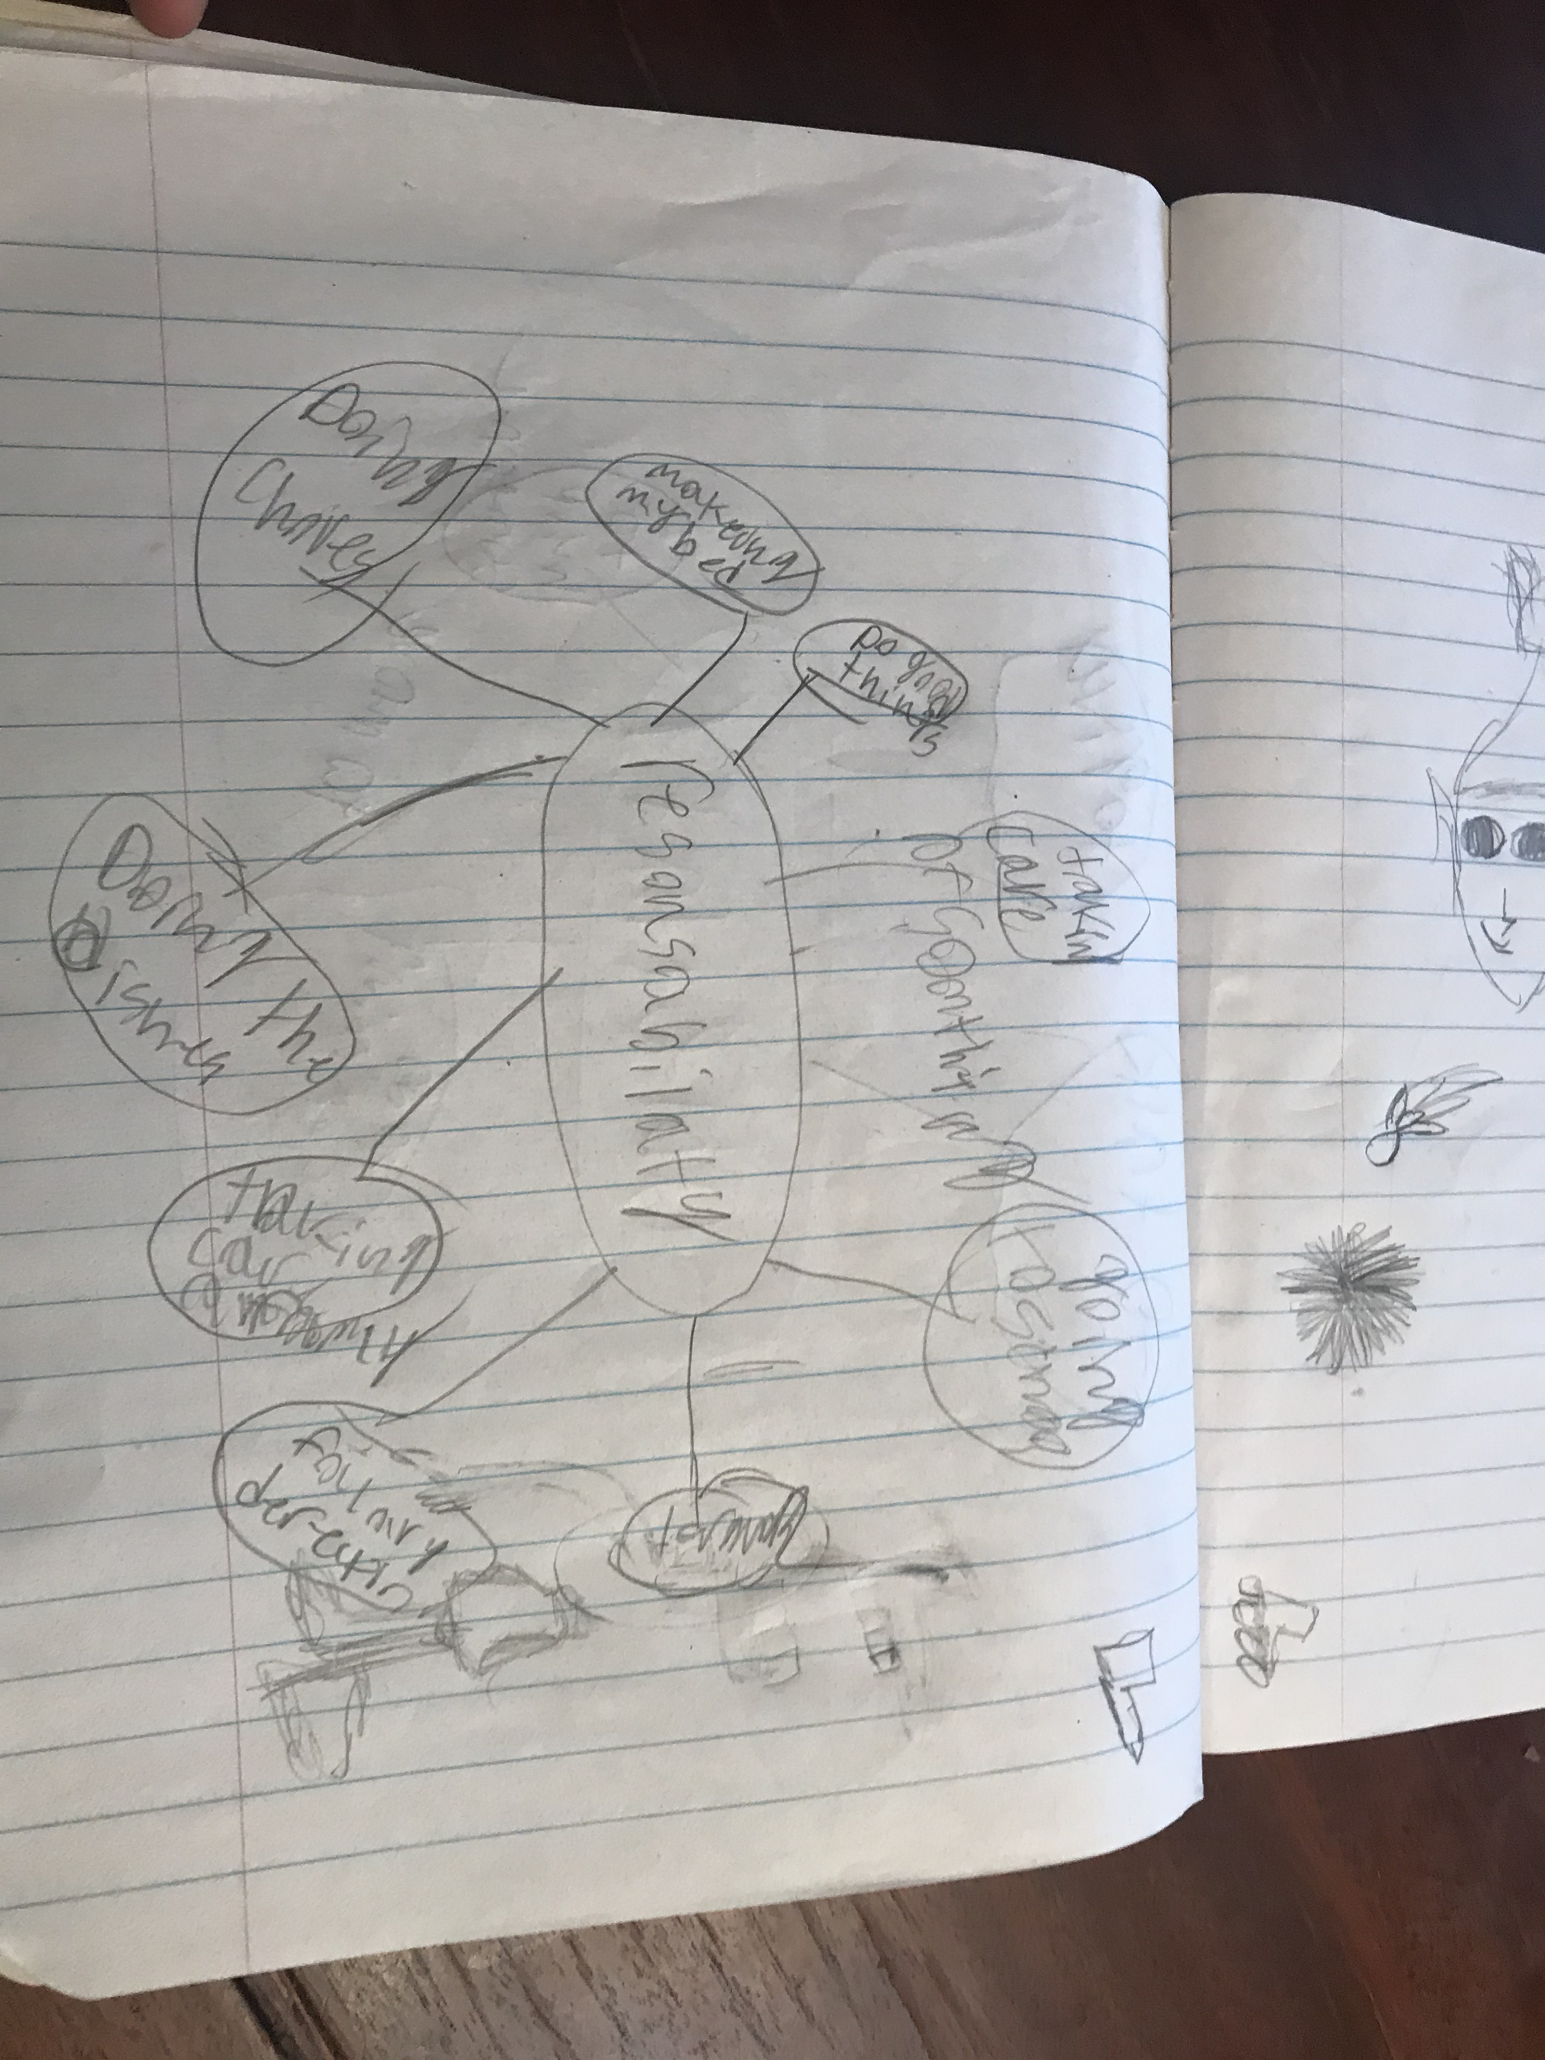  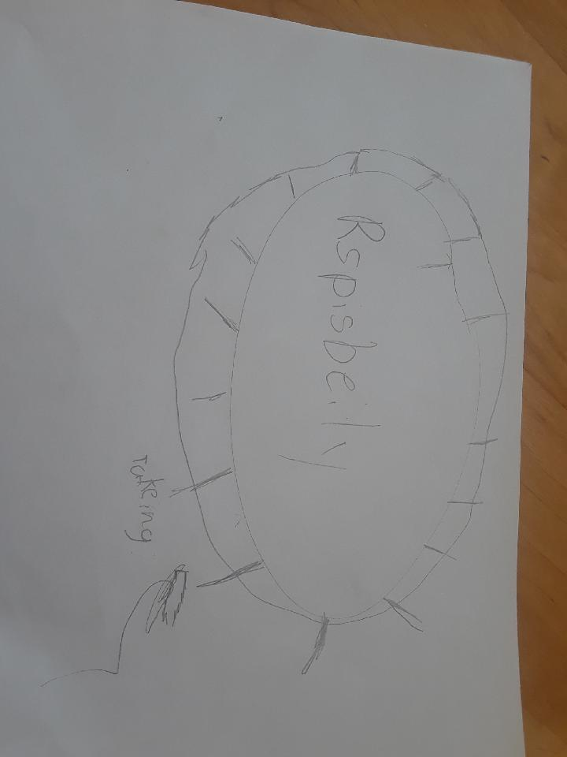  As a result of going through the discussions, videos about how the mothers took care of their offspring and how the students’ mothers and they themselves demonstrate “responsibility,” students were able to add information to their concept web to explain what it means to be “responsible.” The web demonstrates each student’s personal understanding of the word and what important information they comprehended from the discussions and videos - no two webs are alike. The various means for which the word “responsibility” was portrayed in the story and discussion, and in the kids’ videos where the kids demonstrated and explained how they interpret the word, gave students a wide variety of opportunities to “see” the word ”responsibility” in action. There were those students who got a lot of good definitions, and there were those like the last entry that didn’t take any notes. For this student, it was easier for her to explain her understanding rather than to write it down. She needed more support as far as walking her through the steps and helping her to see that practicing responsibility is a natural process.
Next Steps | After reading the story and showing the videos, I would probably pull students aside in small groups with the students, according to ability, to discuss the story and video. This would give students who need more time to process, more opportunity to ask questions and talk about ideas aloud. This would give higher ability students the time to discuss the content at a deeper level. We would still come together as a whole class to share out what was discussed so that all the students could benefit from one another’s ideas. However, small groups would give some students more time to process the new learning. In small groups, more time could be spent discussing the word and taking each piece of the activity a bit slower, giving those who may need more time to talk about the meaning of the word and process the information the opportunity to do so. This may be just too much information all at once for some students. Changing the pace of the activity supports some students’ mode of learning, and creates a better opportunity for them to understand the concept better.
Evaluation | The variety of lessons for this activity helped the students see “responsibility” used in different situations and interpreted in a number of ways. The variety also met the needs of different types of learners as well. Some students could relate to the story while others really found understanding watching the videos of students who were older than themselves. I would use this activity again to teach responsibility, however the next time I do this, I would break up the activity into smaller chunks. I would do Part 1 and 2 together – have students discuss the picture and watch the Horton video. This would give us more time to discuss and give students the opportunity to do a better job of jotting down notes on the concept web and share out any thoughts or connections students made to what they already know. Then, I’d do Parts 3 and 4, watching the video of the kids giving their definition of the word Responsibility and part 4 looking up the definition and comparing it to their understanding of the word. Again, giving students more time to really compare the actual definition to their own understanding will confirm or give them insight to the full breadth and depth to the word responsibility. This would better prepare them for Activity #2 where students put that definition and understanding into action, especially through the lens of the Hawaiian word “kuleana” which is more relational – a reciprocal, mutual relationship.

CASE STUDY CAPTION:
What the document is? This is the actual implementation of Activity #1. It describes what needs were specifically being addressed and the action that was taken to address those needs through the activity. After the activity was completed, this case study outlines the results of the action taken and provides three student samples as evidence of the activity. The three student samples demonstrate the wide variety of learners who participated in this activity. After executing this activity next steps were described based on the outcome of the activity to improve the overall effectiveness of the activity with students. The case study ends with an evaluation that shows that Activity #1 was effective, yet could have been improved by breaking down the activity into two separate parts.
Why it is evidence? This is evidence of Activity #1 being effective in helping students understand a deeper meaning of responsibility as portrayed in the picture, story, videos, and discussion because the understandings are clearly written on two of the students’ concept web (as shown above). For the majority of students, they were able to come up with a variety of meanings based on what they experienced in the activity. For others (like the last concept web shown), the activity needed to go a little slower and the student needed to be given more supports along the way.
What it is evidence of? This is evidence of the effectiveness of intentionally teaching a concept like responsibility to make students more aware of what it means and the positive impacts it has on self and others. This is something that may not be instinctive, nor may anyone be born with this innate trait of being responsible. As stated in the rationale, it is something that, more than ever, needs to be stated, pointed out, discussed, and practiced to develop an awareness and a habit for the benefits of the student, his/her realm of influence, and the greater community.

CASE  STUDY MANAGEMENT | Date of Action: April 2020  Activity #2: Students will use what they learned from Activity #1 and put all of that understanding of “responsibility” into transitioning to the word “Kuleana” and putting kuleana into action. Kuleana is a deeper understanding of “responsibility” – a reciprocating relationship. Students will practice first with a boiled egg that represents another human being, and then students will implement their understanding of kuleana in real time by practicing with family, friends, school, or the community.
Need(s) Addressed | Building upon what was addressed in Activity #1 where the word responsibility was explored through various parts, and students deepening their understanding of responsibility, in this second activity, students put their knowledge into practice through an egg activity and actually demonstrating responsibility with family, friends, school, and/or community. Students need to practice how and when to be responsible so that they are more aware of what they can contribute to the greater good. Practice will develop habits and the intent is for students to recognize a need and act upon that need by displaying responsibility. A deeper meaning of responsibility is introduced in this second activity where students transition to the word kuleana – responsibility that is relational and that reciprocates.
Summary of Action(s) | To address these needs, students transitioned from the word responsibility to the word kuleana. The difference between the two were explained and discussed. Students were then given the task of demonstrating kuleana to a boiled egg – treating it as though it were a little human being. They had to care for it, and take with them wherever they went over the weekend. We discussed how this was a reciprocating relationship – that if this were a real being, that this being was reliant on them and that they were responsible for the being. If this were a real being, what would they get out of taking care of this being? At this point, our discussion transitioned to how their moms and dads took care of them and what their parents got out of it…love, happy times, etc. Following this, students needed to decide who there were now going to practice kuleana with – family, friends, school, or community.
Result(s) of Action  (Student evidence) | 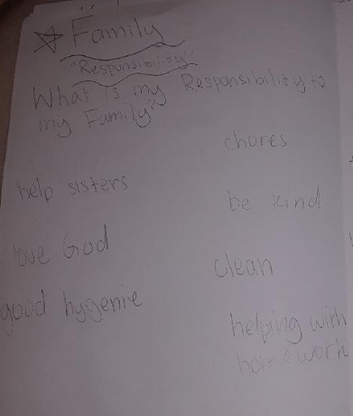  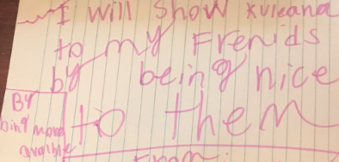  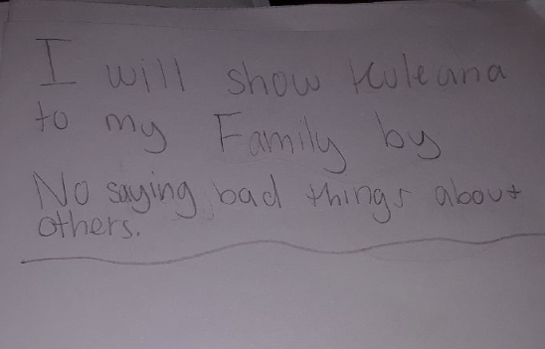  As a result of students exploring kuleana in terms of self, family, friends, and community, students chose one area that they wanted to work on for one week. Students used the ideas from their web to determine how they would demonstrate kuleana with either their family, friends, school, or community. By going through and delving deep into each of the areas, family, friends, etc. students were able to see which area they needed to work on and which area they had control over to make an impact. These three student samples show what they chose to work on. Some students needed a lot of prompting to be more specific on what they would be working on – as seen in the second part/sentence that they wrote. Questions like, “How are you going to show kuleana to your family? What specifically are you going to do to show kuleana? What would I see if you were demonstrating kuleana?”
Next Steps | Following the students’ intentional implementation of kuleana with either family, friends, school, or community, students will continue to demonstrate kuleana (as the student specifically stated), and their parent/guardian will be asked to observe their child for a week to see if their child demonstrates kuleana as described. At the end of the week, parents will answer questions such as, “Did you notice your child demonstrating kuleana by _______? How much effort did he/she put into it each day?” Other next steps include practicing the same kuleana, but with a different group of people. For example, if the student chooses to not say bad things about others within his/her family, the student would then choose another group of people to demonstrate the same kuleana (i.e. friends at school, friends in the neighborhood).
Evaluation | This activity proved to be quite successful in helping students demonstrate what they learned about kuleana. It’s one thing to know and learn about a concept. It’s a different story when the concept is implemented and practiced to make a positive impact on self and others. For all of the students, this transition from concept to application was not a natural process. They needed a lot of prompting and guidance. Some of the struggles were to try and convince them that kuleana is a GOOD thing, and not something negative. I understand that as a child, being “told” what to do on how to “be” responsible can come across as a negative connotation. We had to really talk about how kuleana is beneficial to not only the recipient, but the giver as well. And sometimes, the recipient may not acknowledge the giver positively or at all, and that’s okay! The idea is that the giver did what he/she needed to do and to find satisfaction in knowing that he/she did the right thing. And down the line, that they will see some benefit from their actions of expressing kuleana – a positive change in attitude of self and/or other people, if expressing kuleana in the community, seeing less opala and a more beautiful landscape, or if expressing kuleana in the family, seeing siblings get along better. These are just a few of the benefits we discussed to look for – not right away, but eventually. This was not easy for the students to conceptualize, but the hope is with more intentionality, discussion and practice, students will see the long term benefits of fulfilling kuleana.

CASE STUDY CAPTION:
What the document is? This document shows which specific area the students intentionally worked on to demonstrate “kuleana” for one week. This document states exactly what the students chose to practice kuleana after doing the egg activity. This document also talks about next steps as a result of the activity. It also shows the meaningful discussion following the activity and how practicing kuleana is not something that is easy for students to do, but something that they will need more practice with, especially when the recipient does not acknowledge the giver and the giver may need to adjust their way of thinking to see that what they have done may just be an intrinsic benefit at first or only.
Why it is evidence? This is evidence of learning because students gained a richer understanding of the term “Kuleana” than they expected. From the discussion following the activity, their expectations for demonstrating kuleana were not as they realized. Their disappointment and confusion lead them to see that putting little effort into demonstrating kuleana produces shallow results. Discussions also revealed that recipients may not acknowledge the giver right away or at all and that’s okay. It’s not a “give to get” mentality, but by giving, one will reap the benefits.
What it is evidence of? This is evidence of how the implementation of the intentional practice of kuleana positively affected students because from the evidence, students came up with ways they could demonstrate kuleana with their chosen group of people (family, friends, school, or community). This is evidence of students learning the meaning of “kuleana” through their intentional actions with family and friends. Students learned that their demonstration of “kuleana” may not always trigger a response from the recipient and further came to the understanding that no response doesn’t mean that they don’t get anything in return. That return could be an intrinsic reward or something that they may see or experience later on.

SECTION 5.

Implementation Reflection: Participants will provide a written reflection that addresses how their activities and actions impacted student’s achievement and behavior, identifying which activities and actions they will continue to use in the future, what activities and actions they will refine, or if they will discontinue using the activity all together. (Activity/Action Centered and how it affected Student Growth)

Implementation Reflection Activity #1

Activity #1 provided students with the content necessary to practice kuleana. It was an introduction to the word “Responsibility,” what that means, and what it looks like. It gave students the opportunity to relate the word to what they understand it to mean and more importantly, to broaden their understanding with other definitions of the word. Activity #1 provided a wide range of meanings for students to relate to and to explore. The activity was successful with all of the students because some found understanding in the story, some found understanding in the videos, and some found understanding in the discussions. Although one student wrote only one thing on her web, she could at least talk about it and the story and videos prompted the discussions. Students achieved a deeper understanding of the word “Responsibility” which prepared them for the next activity, Activity #2 where they put their understanding into action. Activity #1 fostered student growth because it affirmed some of their current responsibilities, which made them feel good that they were already doing and this affirmation contributed to increasing the frequency of demonstrating responsibility and perpetuating this positive behavior in other areas of responsibility.

In the future, I would definitely use this activity again to have students affirm and broaden their understanding of responsibility. Over the years, I may update some of the stories and/or videos to keep the content current and relevant to students. However, the idea of exposing students to a variety of ways to understand the word “Responsibility” has proven to be worthwhile in positively changing student’s thinking and behavior. I may even consider spending more time in this area to really delve into deeper discussion about how these stories/videos demonstrate responsibility. It may develop into a unit plan that could be a reoccurring theme throughout the school year as well.

ACTIVITY #1 REFLECTION CAPTION:
What the document is? This document is the Implementation Reflection for Activity #1. It’s the teacher’s reflection of how Activity #1 went and how the activity impacted student achievement and behavior. It explores the effectiveness of the activity on student’s actions as well as the strengths of the activity and how that increased student growth.
Why it is evidence? This is evidence of a reflection because it shows the teacher looking back on implementation of Activity #1 and how the results of the activity changed and modified student and teacher behavior. The reflection outlines what was done and how the activity impacted student growth and achievement. Students participated by reading the story, watching videos, and discussing the word “Responsibility” and through that all, students gained a better understanding and modified their actions to perpetuate the positive impact of demonstrating responsibility.
What it is evidence of? This is evidence of how intentional planning and providing a variety of ways to understand what responsibility means is an effective tool in increasing student learning and positively modifying behavior. This is evidence of the power of discussion in formulating the desire to demonstrate and practice continually, the act of being responsible. This is also evidence of a teacher reflecting on the strengths of the activity and the benefits of continuing to use this activity to instill the desire to perpetuate the demonstration of responsibility in her students. Modifications may be made to keep the content current, but the main idea of practicing responsibility is maintained.

Implementation Reflection Activity #2
Activity #2 was putting what was learned from Activity #1 into action. Activity #1 provided the content and background for students to use in Activity #2. Students had the opportunity to choose how they were going to demonstrate responsibility and with whom they were going to practice on. Activity #2 also introduced a dramatic transition from the word “Responsibility” to the deeper Hawaiian meaning of “Kuleana.” We discussed “kuleana” as a relational type of responsibility. Hawaiians believe, for example, that if you demonstrate “kuleana” to the land or ocean, the land will take care of you. It’s a reciprocal type of relationship where there are more benefits when there is more investment in the relationship. But, it’s not a “give to get” mentality either. It’s the idea that the genuine investment poured into kuleana produces benefits seen and sometimes unseen.

Students cared for a boiled egg as well as demonstrated “kuleana” with their chosen group of people (family, friends, school, or community). For the boiled egg task, students found that taking care of the egg and protecting it from harm (cracking) took effort. All of the students created a “safe haven” whether it be a box or cushion, to protect the egg from rolling and potentially cracking. As a result of this task, students found it a bit cumbersome to constantly make sure that the egg was with them at all times and that the egg was always placed on a firm foundation. Students related this to how their mothers and fathers demonstrate “kuleana” when they take care of them and realized that it takes effort and extra attention to make sure children are taken care of and safe at all times. We discussed that although it may seem like a chore to take care of children (and practicing kuleana) there are fun times and the reward of seeing them grow and mature and become independent is worth all the “teachable moments.” The second part of the activity was to demonstrate “kuleana” to family and friends. Students found that when they demonstrated “kuleana” with their family and friends, they didn’t always get the positive feedback they expected. We discussed that this is what may happen and when it does, they can still walk away from the experience with a positive outlook.

I would definitely do this Activity #2 again because it proved to be worthwhile and engaging for students (and parents!). It was a good hands-on activity that was fun for the students and it prompted a lot of discussion among students (and at home!). However, looking back, I would probably have the students work in a small group first before practicing “kuleana” alone on their own. Working in small groups first would give students the opportunity to dialog with one another about what works, what doesn’t work, how to handle their recipients’ reactions and/or non-reactions, how “kuleana” is a reciprocating relationship, etc. Within the small group, I would give them a few questions/prompts to guide their discussion, like “What do you expect the person you are showing ‘kuleana’ to will say or do as a result of your actions?” Then, with more experience with practicing “kuleana” as a group, students would be able to have a better expectation on doing it on their own because they wouldn’t be so surprised and they would know how to react and respond better. Not that the small groups would prepare students for every situation, but I felt that it would at least have prepared them a bit more for what they may have had to face and how they could have better handled the situation. I also felt that my interjections to help students make that connection was done a little bit too much and too often. I think that if students had worked in groups first, they would have been able to come to that understanding as a group without having me do all the thinking and connecting for them. It might have taken longer for students to come to that conclusion, but the mental exercise would’ve been more meaningful and something that they would’ve remembered and better retain on their own.

ACTIVITY #2 REFLECTION CAPTION:
What the document is? This is the Implementation Reflection for Activity #2. The teacher has implemented the activity and is now reflecting on the effectiveness of the activity with the students. The reflection describes the impact the activity made on students in terms of how they view kuleana and how they demonstrate kuleana with family, friends, school, or the community. The reflection also describes the teacher’s reaction to the activity, its positive impact on students, and how the activity would be modified to improve student engagement and growth.
Why it is evidence? This is evidence of a reflection on the implementation of Activity #2 because it outlines what happened during the implementation and how the students reacted to the activity of taking care of an egg and practicing kuleana with friends and family. This is also evidence because it shows the teacher reflecting back on what happened during implementation and making modifications to the activity to obtain better more meaningful results from students in the future. For example, one modification would be to have students discuss in small groups prior to implementation, so that they would be better prepared for implementing kuleana with their family and friends.
What it is evidence of? This is evidence of the importance of giving students the opportunity to put what they have learned into action. Just listening and watching content lessons isn’t enough for students to understand and retain what is being taught. Students need to practice and discuss implementation so that when they are faced with a situation, they know how to act and react. The whole concept of school has changed with the growth of technology. Schools no longer disseminate information. Schools now help students understand how to apply what they are learning. Schools are “training sites” so that when they go out into the real world daily, students are somewhat equipped to positively act and reactin given situations.

SECTION 6.

Culminating Reflection: Participants will reflect on their personal and/or professional growth though this learning process. They will provide a summary of information learned and how they can apply it to meet the needs of future students. (Teacher Growth Centered)

Culminating Reflection

This course has revealed that students of all academic levels can learn when an activity is presented in a way that allows students to actively engage in the learning. As seen in the results of these activities, all of the learners learned something about the content as well as something about themselves.

This new knowledge gained from taking this course, going through the course content, and using the content with actual students has literally transformed the way I view teaching. The old understanding of teaching where the teacher was the one to impart knowledge and control the learning outcomes to the point of stifling student participation, thinking, and creativity has been replaced by the new understanding that a teacher, still working in the realm of being accountable using standards, allows students of all ability levels to be an active participant in his/her own learning. Activities like these that emphasize kuleana can be used in all subject areas and in all class settings to set students up for success because it is the student who takes the learning into their own hands and moves it forward, with the guidance of the teacher. For example, with one of the students who participated in this activity, she was not academically strong, and not self-motivated. But by going through the activities, she was able to engage in the learning and fully participate in the discussions and even the egg experiment. Her learning many not have been like that of the other two students, but there was learning that occurred and she felt good about the outcomes. The hope is that this experience of teaching specifically to the HA Framework will motivate students like her to participate even more the next time and really engage herself in the task.

This change in how students view their role in the community will continue to support student learning even after this course has ended by giving students a wider range of opportunities to participate in the learning through the HA Framework, helping them to truly understand the holistic learning behind HA and its universal applications to genuinely guide students into being well equipped and knowledgeable decision-making leaders of tomorrow for the benefits of everyone in the community. As experienced with the students in the activities, much of the learning occurred when the students discussed their common understandings and experiences with the teacher and their peers – learning through dynamic relationships.

Feedback from peers/colleagues proved to be very helpful in making the second activity richer and more meaningful. My peer asked me to define “kuleana” and show how this project is deeply rooted in the Hawaiian culture – not just “use” kuleana in the activity, but make students aware of “kuleana” as they were going through the activity. He suggested the idea of a culture-based approach and how that leads to positively impacting multiple academic subject areas and life skills. This suggestion gave students a more meaningful and deeper approach to the task showing them that “kuleana” is a mutual relationship - give and you will receive. Another suggestion was to incorporate Social Studies standards instead of just Language Arts standards to make the activity more complex because the task actually does encompass multiple subject areas. The third suggestion was to describe in detail how the students were going to share out with one another. Students shared through Google Meet and provided feedback using the same venue. Lastly, he asked how this learning task would help students transfer the knowledge and skills learned to make a difference in their own life, with family or friends, or in the community. As a result, I added more details to the task by specifically explaining how students would “make a difference” and what the students would learn from the experience.

In my job situation, this course provided me with a better understanding of current teacher practice in our schools today. I learned more about the HA Framework, especially “Responsibility” and what that looks like with students at the elementary level. This new learning provides me with a broader perspective of what teachers are presently using to drive student learning and achievement. I will use what I have learned to better dialog with new teachers and complex level administrators when discussing possible scenarios for Classroom Observations, Student Success Plans, and School/System Improvement Plans. I will adapt what I have learned about “kuleana” when conducting training with new teachers and use the HA Framework in the training so that they can see the benefits of it and point out that they can use this effectively in their classroom as well.

CULMINATING REFLECTION CAPTION:
What the document is? This is the overall course reflection after all of the tasks and reflections have been completed. This reflection talks about new knowledge/insights gained and how that new knowledge is used to improve instructional practice and support student learning. It also explores how the instructor questions, comments, and/or feedback supported/impacted teaching and/or student learning.
Why it is evidence? This is evidence of this course being worthwhile in positively and effectively modifying teacher and student behavior because throughout the writing, planning, and execution of these activities new realizations were made and practices were altered to gain the most out of what was being taught. This is also evidence because it meets the intent for this course – to provide teachers with the opportunity to learn more about the HA Framework which doesn’t replace the General Learner Outcomes (GLO) but enhances it.
What it is evidence of? This culminating reflection is evidence of how this course has made me more aware of the HA Framework, specifically the “Responsibility” portion, and how it goes hand in hand with the General Learner Outcomes to provide our students with a well-rounded curriculum that intentionally gives students the opportunity to apply the concepts to real life. The benefits to this are endless! Intentionally teaching students kuleana not only helps relationships in the classroom, but the hope is that the behavior will transfer over well to friends outside of school, family, and the greater community for many years to come. Students need to be aware of kuleana and how important and beneficial it is when living among a diverse group of people. If students can learn, understand the benefits of, and practice this at an early age, and this is reinforce throughout their years of schooling, then we as educators are doing our part in preparing the next generation to positively impact the world!

